Exercise 9 Implementation of ES6 Features in React Using Functional Components and Conditional Rendering
Aim
To create a React application that demonstrates the use of ES6 features such as map(), arrow functions, array destructuring, spread operator (merge arrays), and conditional rendering using React components.

Objectives
- To understand the features of ES6.
- To implement the map() method.
- To use arrow functions.
- To apply array destructuring.
- To merge arrays using the spread operator.
- To implement conditional rendering in React.

Software Requirements
- Visual Studio Code
- Node.js
- npm
- React

Procedure
- Create a new React application named cricketapp using Create React App.
- Open the project in Visual Studio Code.
- Create components:
  - ListofPlayers
  - Scorebelow70
  - OddPlayers
  - EvenPlayers
  - ListofIndianPlayers
- Declare an array of 11 cricket players with their names and scores.
- Display all players using the map() function.
- Filter and display players having scores less than 70.
- Create two arrays named T20players and RanjiTrophyPlayers.
- Merge both arrays using the ES6 spread operator.
- Use array destructuring to display Odd and Even players separately.
- Use a flag variable in App.js to conditionally display either:
  - List of Players and Players with score below 70, or
  - Odd Players, Even Players and Merged Indian Players.
- Execute the application using:
npm start
- Open the browser at:
http://localhost:3000

Components Used
- App.js
- ListofPlayers.js
- Scorebelow70.js
- OddPlayers.js
- EvenPlayers.js
- ListofIndianPlayers.js

ES6 Features Used
- Arrow Functions (=>)
- Array map()
- Array filter()
- Spread Operator (...)
- Array Destructuring
- Conditional Rendering

Output
When flag = true
- Display all cricket players with their scores.
- Display only the players having scores less than 70.
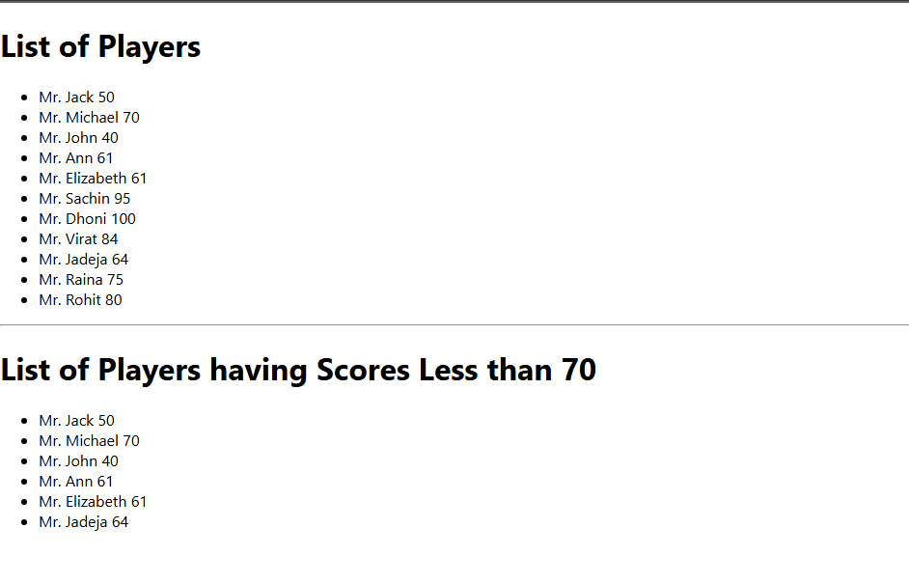

When flag = false
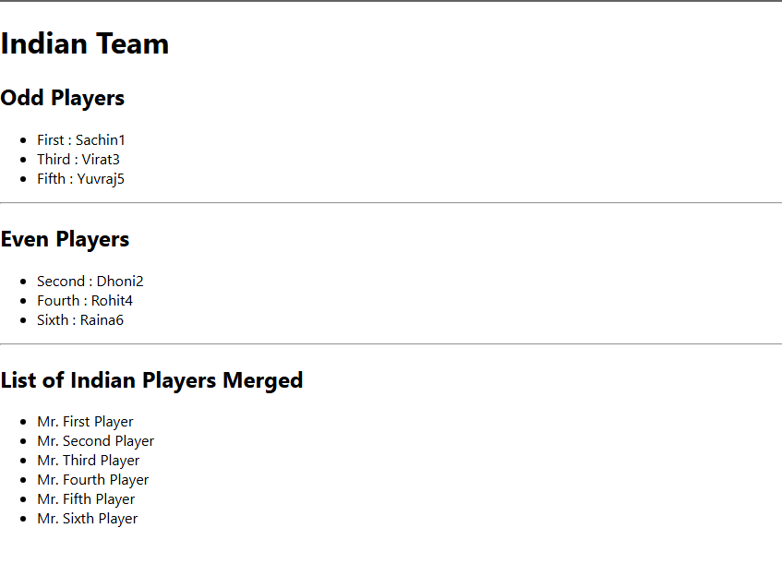

Result
The React application was successfully developed to demonstrate various ES6 features including the map() method, arrow functions, array destructuring, spread operator for merging arrays, filtering, and conditional rendering using React components. The application displayed the expected output successfully.

